**PROJECT GREEN**

# 18CHAA0 - ENVIRONMENTAL SCIENCE

#### Submitted by

##### Dinesh Kumaar M S

***21C025***

***and***

##### Praveen Kumar T

***21C072***

***And***

***Abishek M***

***21C004***

#### Guided by

## ***Dr/Mr. XXXXXXX***

Professor/Asst. professor/Lecturer

# *Department of Chemistry*

### **THIAGARAJAR COLLEGE OF ENGINEERING**

(An Autonomous Institution Affiliated To Anna University)

**MADURAI – 625 015**

***April 2022***

###### **THIAGARAJAR COLLEGE OF ENGINEERING**

**(An Autonomous Institution Affiliated to Anna University)**

**MADURAI – 625 015.**

CERTIFICATE

Certified that this is a bonafide record of the 18CHAA0 Case study & Viva Voce done by Mr/Ms.XXXXXXXXXX (Register Number) and Mr/Ms.XXXXXXXXXX (Register Number) of Second Semester B.E/B.Tech ____________________________ during the year 2021 - 2022.

Signature of the Guide Signature of H.D.CHEM

Station: Madurai Date:

Submitted for Viva-Voce examination held at Thiagarajar College of Engineering, Madurai – 625 015, on __________________.

INTERNAL EXAMINER EXTERNAL EXAMINER H.D.CHEMISTRY

CERTIFICATE

This is to certify that the **18CHAA0 case study** report entitled ***“Title”,*** being submitted by Mr. Dinesh Kumaar andMr. Praveen Kumaar and Mr. Abhisek

**Mr/Ms. xxxxxxxxxxxx Dr/Mr. XXXXXXXX**

**(B.E. STUDENT) (GUIDE)**

Station: Madurai Date:

## **LIST OF CONTENTS**

|  |  |  |
| --- | --- | --- |
| **Chapter No** | **TITLE** | **Page No.** |
|  | Title Page | i |
|  | Bonafide Certificate | ii |
|  | Certificate | iii |
| 1 | INTRODUCTION. | 1 |
| 1.1 |  |  |
| 2 | LITERATURE REVIEW |  |
| 3 | PROBLEM DESCRIPTION |  |
| 4 | METHODOLOGY / EXPERIMENTAL SET-UP |  |
| 4.1 |  |  |
| 4.1.1 |  |  |
| 5 | PRESENT WORK |  |
| 5.1 |  |  |
| 6 | RESULTS AND DISCUSSIONS |  |
| 7 | CONCLUSION |  |
|  | REFERENCES |  |

**ABSTRACT**

33% of the Earth's soils are already degraded and over 90% could become degraded by 2050 (FAO and ITPS, 2015; IPBES, 2018). The equivalent of one soccer pitch of soil is eroded every five seconds. (FAO and ITPS, 2015). This is significantly related with the decrease in tree cover over years. In India, there is a notable increase in the soil degradation across many states, while comparing the last two decades. And Tamil Nadu is no exception to it. All these statistics are supported by the charts (Fig1, Fig2, Fig3) below. The existing methodologies for preventing soil erosion are planting vegetation, reforestation, matting and Terra-seeding. Currently, NGOs work towards this goal by distributing plant saplings. But finding the appropriate lands is the main problem they face.

Our proposed methodology accommodates and simplifies all these existing methodologies, which is a platform built to connect the landholders and the NGOs who work on tree plantation and soil protection. This method doesn’t cost anything excess and this will also suggest the best plan according to the requirements of the landholders. The land will be got on free lease and it will be safely returned when the land owner feels to procure the land back (after a minimum period). Hence this could be the best cost-effective methodology.

**CHAPTER 1**

# INTRODUCTION

**1.1 Soil’s Role**

Soil is the only magic material that turns death into life but it itself becomes dead when it loses the death matter.

Soil and trees are the two most important elements that maintain the balance in the environment. Soil is another home for a million of organisms ranging from a micron sized bacteria to earthworms. Soil provide anchorage for roots, help in holding water and nutrients. It’s irresistible fact that soil plays a vital role in maintaining Earth’s ecosystem.

**1.2 Our Aim**

our project is aimed at preserving soil by building a app that would integrate willing landowners who are ready to give their land for lease for free for a period of time and volunteering individuals and organizations that are ready to give green cover to that land. According to the recent surveys conducted by various sources listed below, soil erosion is the modern day problem.

CHAPTER 2

**Literature Review**

* 1. **Creation of Waste Lands**

Wasteland is caused due to many factors. Areas that are damaged by water logging, ravine, gully erosion, riverine lands, salinity, and alkalinity, shifting and sand dunes, wind erosion, extreme moisture deficiency, overexploitation or natural resource, a dump of industrial and sewage wastes, soil erosion, deforestation are some of the causes of wasteland.

Water, wind, man and other source are causing agents for Wasteland. There are two factors of wasteland – Utilisable Waste Land, Un-Utilisable Waste Land. Utilisable Wastelands include marshy lands, saline lands, and undulating lands. Rocky land, Glacier Land and Deserts are part of Un- utilizable wasteland. We are considering waste lands created by man.

Barren lands are created when that land is less important to the owner. Some of the ways are,

* During construction of house, Plan is not well optimized such that there will be some land where no building can be constructed or used. That land is left empty.
* Some of them will buy the land and have the plan of constructing building, but due to budget constraint they cannot start construction. During that time Land is just left. We can use that land too.
* Some of the rivers like Vaigai are almost dry now. Weed plants will grow ,that is useless. We can use upper zone of the river. Even if rain hits , only deepest part will be covered with water whereas land little bit upper if safe. We can use that too.
* Lands around railway lines will be held by Government. These lands are not used for construction, due to sound pollution caused by trains. But it won’t affect the plants. So we can those lands can also be used.

**Chapter 3**

**Problem Description**

Realizing the importance of availability of reliable database on the wastelands of the country, the Union Minister for Rural Development, Agriculture and Farmers Welfare & Panchayati Raj, Shri Narendra Singh Tomar released the Wastelands Atlas – 2019. The Department of Land Resources in collaboration with National Remote Sensing Centre (NRSC), Department of Space has published Wastelands Atlases of India - 2000, 2005, 2010 & 2011 editions.  The new wastelands mapping exercise, carried out by NRSC using the Indian Remote Sensing Satellite data is brought out as the fifth edition of Wastelands Atlas – 2019. India with 2.4% of total land area of the World is supporting 18% of the World’s population.  The per capita availability of agriculture land in India is 0.12 ha whereas World per capita agriculture land is 0.29 ha.  Unprecedented pressure on the land beyond it’s carrying capacity is resulting into degradation of lands in the Country.

This Wastelands Atlas-2019 provides district and state wise distribution of different categories of wastelands area including mapping of about 12.08 Mha hitherto unmapped area of Jammu & Kashmir. The changes in wastelands between 2008-09 and 2015-16 have been presented in the Atlas.  The effort has resulted in estimating the spatial extent of wastelands for entire country to the tune of 55.76 Mha (16.96 % of geographical area of the Country i.e. 328.72 Mha) for the year 2015-16 as compared to 56.60 Mha (17.21%) in the year 2008-09.

The wastelands have undergone positive change in the states of Rajasthan (0.48 Mha), Bihar (0.11 Mha), Uttar Pradesh (0.10 Mha), Andhra Pradesh (0.08 Mha), Mizoram (0.057 Mha), Madhya Pradesh (0.039 Mha), Jammu & Kashmir (0.038 Mha) and West Bengal (0.032 Mha). Majority of wastelands have been changed into categories of ‘croplands’ (0.64 Mha), ‘forest-dense / open’ (0.28 Mha), ‘forest plantation’ (0.029 Mha), ‘plantation’ (0.057 Mha) and ‘industrial area’ (0.035 Mha) etc. But large part of land is still empty.

**Chapter 4**

**METHODOLOGY**

**4.1 PROPOSED SOLUTION**

Large areas of land are left unused around the world .These lands are owned by the governments , private organisations , and individuals. Owners who aren’t immediately interested to use their land for construction leave their land empty and the land is left with weeds to grow. Weeds are unwanted plants that not only recede the soil fertility but also their presence hinders a lot of work . This inturn increases the soil erosion and eventually leads to soil death **.**

The solution presented is to grow native trees on the barren soil. Unfortunately, the work and the expenditure involved was not bearable by individual owners and various other reasons are reported for the same by the owners.

The explication to this problem is by building and developing a platform that would connect the willing landowners who are ready to lease their land and volunteering individuals as well as NGOs

The platform that we choose is app. Idea is to create a app that connects between a land owner and willing volunteer who is ready to work in the land. App will ask primary information about the user. Main page contains two options .That include Ready to rise and Ready to give. Users who want to give their land can host it in our app. Those land will be shown to the people who are around that region will be notified about the land. Any volunteer can apply to work for that land. After hand-sake between land owner and volunteer , they can work together. More than one volunteer can work on the same land. Profits from the land can be shared between them. Land is also profited with nutrients and micro minerals.

**4.2 Wireframe of the app**

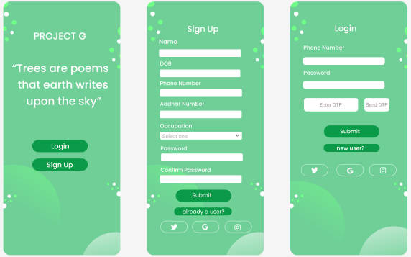

figure 4.1

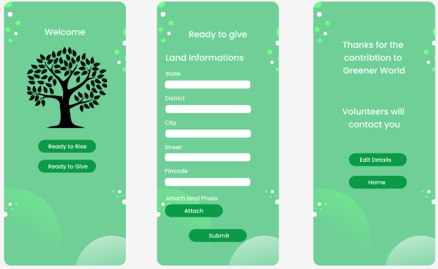

Figure 4.2

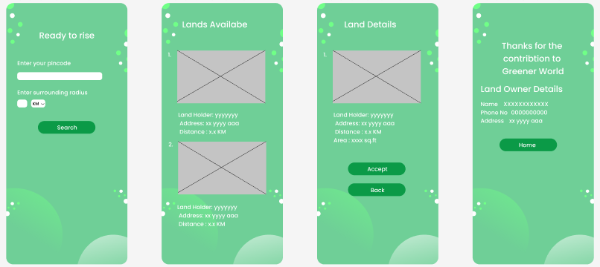

Figure 4.3

CHAPTER 5

PRESENT WORK

In India , there are many individuals like Jadav Molai Peyang(figure 5.1) , Shyam Sundar Jyani (figure 5.2), Vidyadharan, Yoganathan(figure 5.4),  Radhika Anand (Figure 5.3) and Shyam Kumar who work on transforming barren lands into tree groves. Apart from these individuals,  NGOs like Green Yatra, Project Taru , Say Trees and Isha Foundation work on this motto.

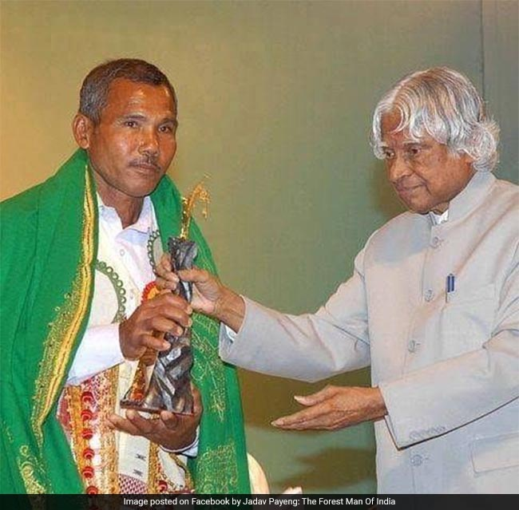 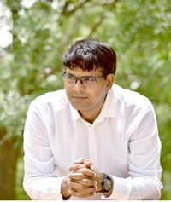

figure 5.1 figure 5.2

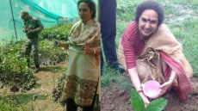

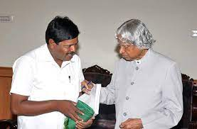

figure 5.3 figure 5.4

CHAPTER 6

RESULTS AND DISCUSSION

6.1 Discussion

Countries have committed to restoring up to 1 billion hectares of land , an area roughly the size of China, according to a new study released ahead of the UN Decade on Ecosystem Restoration (2021-2030).

The website illustrates the goals measured by the UN signatories in the year before 2050 pledging for the restoration of degraded land as large as the landmass of China.

“But what is important to ensure now is that the right trees are planted at the right time, in the right place, and with the support of local communities. And that we uplift the ecosystems that are still somewhat undervalued in these global restoration commitments "

 Quoted by an UN Official ahead of the UN Decade on ecosystem Restoration signifies the importance of the contribution and acceptance by the local communities inspite of pan-world action taken by the signatories of the UN.

 In India , there are many individuals like Jadav Molai Peyang , Shyam Sundar Jyani, Vidyadharan, Yoganathan,  Radhika Anand and Shyam Kumar who work on transforming barren lands into tree groves. Apart from these individuals,  NGOs like Green Yatra, Project Taru , Say Trees and Isha Foundation work on this motto

Something which is common in all their works is either the land is owned by them or they distribute plant saplings to random people. Many NGOs search for land on donation. This is because they don’t get appropriate lands for planting tress

These problems could be collectively solved by our project.This is because a link could be created between the willing landholders and the volunteering individuals/NGOs

A Netherlands based organisation called LandLifeCompany is working on planting and maintaining trees with the help of technology.. Several organisations like  LandLifeCompany having the same final goal  of forest restoration .Our project  will,in turn,be helpful for similar organisations  in enabling the NGOs and landowners in a common communicable platform

Through the method of agro forestry, which involves planting  trees of timber value, fruit trees and medicinal trees , the land holders could also be benefitted.

Kundan Kumar, the IAS officier in charge of Banka district in Bihar, has collaborated with ICAR(Indian Council of Agricultural Research) to to create a similar model for converting barren areas into orchards. The farmers in the district implemented the same methods and are now reaping its benefits. Such projects could also be facilitated by this app.

The targeted end users for this application are the NGOs that are in need of  barren/unused lands, governmental organizations working on ecological balance, educational institutions , individuals involved in afforestation, farmers in loss and landholders.

The project if execution is done properly, well mannered and managed, is excepted to help struggling NGO’s and willing landowners to document and use unused land and degraded land for restoration purposes, thereby increasing overall green cover

CHAPTER 7

CONCLUSION

7.1 CONCLUSION

If our project is implemented with the full support of people, this could turn almost 99% of the unused land into small native tree groves that recover the ecological balance and save the soil from dying.

7.2 FUTURE WORKS

* Improve the UI
* Providing personalised suggestions to the landowners.
* Hassle free and transparent legal procedures to be worked on.
* Get feedback from the users and make changes according to the users.
* Including reward-system.

REFERNCES

[1] Santhoshkumaar ,N. Muralimohan,Dhinaharan,M. Chandru ,P.,Aravindhan, “Site suitability for agriculture from barren land using remote sensing and GIS,” November 2021.

[2] " Conversion of Barren Land into Arable Land,” March

2020.

[3] Damian Carrington, “Tree planting 'has mind-blowing potential' to tackle climate crisis,” 2019

[4] Pasquale Borrelli, Christine Alewell, Jantiene Baartman, “Soil erosion modelling: A global review and statistical analysis,” vol. 780, August 2021.

[5] Gregory Giuliani, Paolo Mazzetti, Mattia Santoro, Stefano Nativi, Joost Van, “Knowledge generation using satellite earth observations to support sustainable

development goals (SDG): A use case on Land degradation,” vol. 88 June 2020.

[6] Amare Aleminew, Melkamu Alemayeh, “Soil Fertility Depletion and Its Management Options under Crop Production Perspectives in Ethiopia,” pp_91-105, Janaury 2020.

[7] Ankita singh, “This IAS Officer In Bihar Converted A Barren Land Into A Forest Cover Using Sustainable Techniques,” September 2020.

[8] K. Sreenivas, G. Sujatha, Tarik Mitran , K. G. Janaki Rama Suresh, T. Ravisankar and P. V. N. Rao, “Decadal changes in land degradation status of India,” vol. 121, August 2021.

[9] Anjali Jhangiani, “Citizens come forward to turn 11 acres of barren land to a mini forest,” June 2021.

[10] Praveen B. Para,” Farmer of Hagarga converts barren land into a self-sustainable green farm,” September 2020

.